**CP Club 365Days Challenge**

**Programming language – C++**

**Problem Statement**

<https://www.interviewbit.com/problems/find-duplicate-in-array/>

**Your Code**:

// 0x71Day of 0x365Days challenge

// VEDANT BHARAD

// 27-12-2022

#include <iostream>

#include <vector>

using namespace std;

int repeatedNumber(vector<int> &A) {

    // slower method

    // for (int i = 0; i < A.size(); i++) {

    //     for (int j = i+1; j < A.size(); j++) {

    //         if (A[i] == A[j])

    //             return A[i];

    //     }

    // }

// return -1;

// faster one

    int n = A.size();

    vector <int> freq(n,0);

    for(int i=0;i<n;i++){

        freq[A[i]]+=1;

        if(freq[A[i]]==2){

        return A[i];

        }

    }

    return -1;

}

int main() {

    int n;

    cin >> n;

    int arr[n];

    for (int i = 0; i < n; i++) {

        cin >> arr[i];

    }

    vector<int> vect(arr, arr + n);

    cout << repeatedNumber(vect) << endl;

    return 0;

}

**Output (Screen Shot)**:

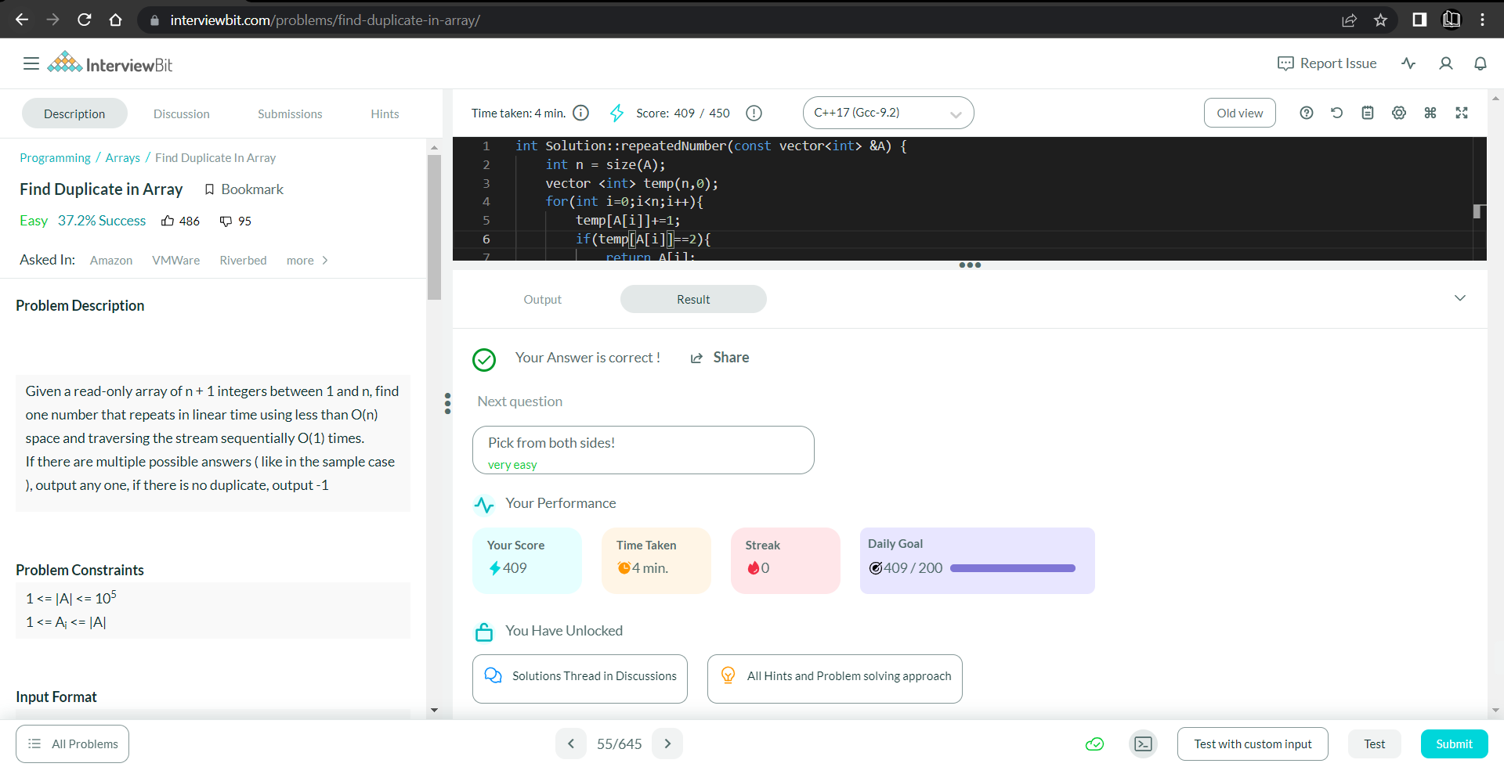

**Understanding about problem:**

* In this task I need to return number which is Duplicate in Array if there is no Duplicate number then return -1.

Note: If you can't understand the problem, feel free to contact us and we'll help you. Please don't copy and paste from anywhere.

ALL THE BEST

Team CP Club